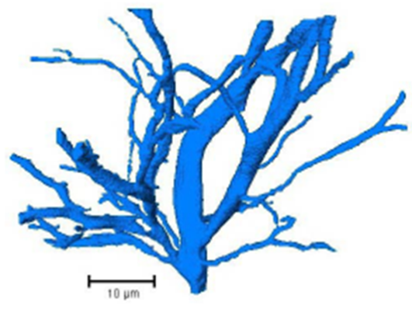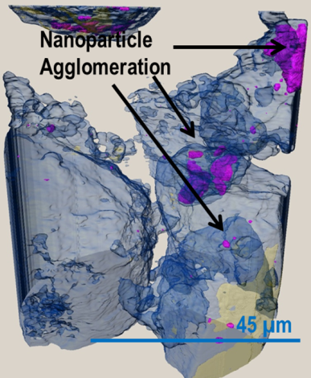

X-ray microscopy (XRM) provides non-destructive 3D imaging capabilities on specimens across a range of length scales, observing features with sizes spanning from nanometers to millimeters. Recent developments, inspired by advances at dedicated synchrotron sources, have incorporated a number of X-ray optical elements that have driven resolution and contrast to levels previously unachievable by conventional X-ray computed tomography (CT) instrumentation.

As the ZEISS X-ray microscopy group continues to develop laboratory X-ray microscopes, building on the technology developed from the company’s synchrotron heritage, we investigate the emerging breadth of applications coming from this new range of instruments.

**2nd February 2015**

**Lanchester (B7), Room 3031, Highfield Campus**

Presented by

Benjamin Hornberger, Ph.D.

William Harris, Ph.D.

Carl Zeiss X-ray Microscopy

Electrical tree degradation in high voltage polymeric insulation

*Schurch et al., University of Manchester*

Manufactured nanoparticle uptake in soybean root structures

Niobrara Shale - 3D Volume Rendering

**Frontiers in X-ray Microscopy …**

**From Synchrotron to Lab**